# The Need

The need for research dissemination is great. One of the twenty recommendations made by the President’s Cancer Panel’s annual report (2004-2005) *Translating Research Into Cancer Care: Delivering on the Promise* directed NCI to: *. . .increase significantly funding for research and implementation activities to improve dissemination and adoption of cancer research advances.*

Although most agree dissemination of guidelines, programs, and policies is a critical final step to improving cancer outcomes, we have not adequately disseminated programs to public health practitioners and underserved communities. Dissemination and implementation of evidence-based intervention programs remains an important issue in addressing cancer health disparities.

Interviews with experienced practitioners and researchers, as well as the guidance of the external planning group for the NCI Research to Reality Mentorship Program, we identified key barriers, facilitators, and competencies that are central to moving ‘research to reality’ and designed the mentorship program based on these findings and feedback.

# What is the Program?

We acknowledge that a mentorship programcannot address all of the barriers or competencies identified in the interviews and review process in one year. However, this *Program* is one component of several collaborative efforts to continue and encourage discourse and training on the translation of evidence-based cancer control and prevention interventions. The *Program* will focus on building the capacity of practitioners to be able navigate within the broad, complex “real world” settings in which evidence-based practice occurs.

The *Program* objectives are:

* Develop six well-matched mentor-mentee relationships
* Improve knowledge, skills, and self-efficacy of mentees within six core EBPH competency areas
* Engage with broader community of practice focused on translating cancer prevention and control research into public health practice to share lessons learned and encourage discussion

# Program Components

The 18-month pilot program consists of three main components, all grounded in theory of experiential learning and adult learning theory:

1. Mentorship and the Mentee Project
2. Training and Support from NCI
3. Online Community of Practice Platform

* + 1. Mentorship and Mentee Project

Mentoring is the core foundation of this pilot and is expected to be a collaborative relationship, however it is expected that the mentee will be responsible for leading this relationship. The mentor is intended to serve as a guide in helping the mentee develop their skills for not only the success of the project, but more importantly, skills and knowledge that can be applied to their work moving forward in their positions and careers.

*“Good mentoring depends on reciprocal learning relationship between mentee and mentor. Together you form a partnership to work collaboratively on achieving mutually defined goals that focus on developing the mentee’s skills, abilities, knowledge and thinking.”*

-Zachary, LJ. (2009). The Mentee’s Guide.

To provide a framework for the mentoring and an opportunity to apply the skills and knowledge gained and build their competencies through experiential learning process, a fundamental component of the *Program* will be the mentee project.

The mentee project must:

* support at least one goal or objective of their local Comprehensive Cancer Control Plan (state, tribe, or territory plans)
* fit within the mentee’s current scope of work with their organization
* mentees, with help from mentors and NCI, will develop a project workplan (template included in materials) to map out deliverables and goals, plan for needed training/guidance to submit to NCI and work toward these deliverables over the year
  + 1. Training and Support from NCI

In addition to the support and training provided by the mentor, NCI will offer additional technical assistance and support for the cohort as a whole.

* Based on the needs of the mentees and mentors NCI will provide periodic training opportunities through webinars and conference call.
* Additional NCI will compile a library of relevant resources and opportunities on the R2R Mentorship Program workspace (described below)
* NCI will host a quarterly conference call for mentees and mentors to facilitate cross-cohort discussion and sharing
* Project coordinator will be available to the pairs as needed
  + 1. Online Community of Practice Platform

The Mentorship Program is a component of the larger Research to Reality Community of Practice (<https://researchtoreality.cancer.gov/>). Given the small number of participants in the pilot, we wanted the opportunity to share the experience with a broader number of practitioners and also to expand the network of public health professionals with whom the participants could engage. The community of practice will be utilized in two ways: (1) Public website and (2) Private workspace

* **Public Website**: Mentees and Mentors will post “stories” on the public facing site to share lessons learned, barriers faced, pose questions to the community to help move the project forward, etc.
  + The site will also feature bios, pictures, and project descriptions for each of the pairs.
* **Private Workspace**: Mentees and Mentors will also have a private workspace on the site in which they will be able to engage with one another. The workspace will offer:
  + A place for discussion with their mentee/mentor and with the rest of the cohort (outside of email) through discussion posts
  + A document sharing and storage space
  + A calendar of events
  + Project management capabilities in the assigning and tracking of tasks.

# EBPH Competencies

To identify targeted competencies for the *Program*, the NCI Working Group reviewed the scientific literature, searched the Internet, and queried organizations and individuals within the field of evidence-base practice for information and references. Competencies reviewed and compared were previously developed by professional organizations and multidisciplinary councils for public health professionals, health educators, and evidence-based behavioral practice.

**What are the 2011 Mentees Focusing on?**

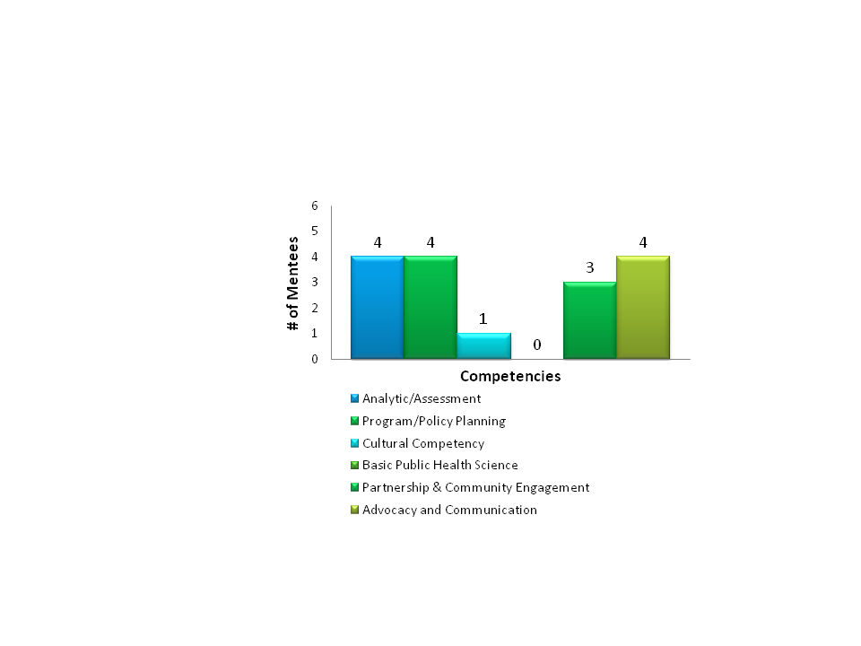

Mentees were asked to identify at least two core competencies that they would like to focus on developing over the course of this program. Their specific project and mentorship experience, in combination with the more general technical assistance and training by NCI, are intended to help build the mentee’s capacity for these skills.

Analytic/Assessment Skills

* 1. Defines and prioritizes problems
  2. Understands how the data illuminates ethical, political, scientific, economic, & overall public health issues
  3. Identifies relevant and appropriate data, information sources, and types of evidence
  4. Makes relevant inferences from quantitative and qualitative data, determines appropriate uses and limitations of both quantitative and qualitative data, and understands the difference between primary and secondary research evidence

Policy Development/Program Planning Skills

1. Collects, summarizes, and interprets evidence-based guidelines and systematic reviews on cancer control approaches
2. Utilizes current techniques in decision analysis and health planning (e.g. PICO, comparing the strengths and weakness of different kinds of research evidence)
3. Develops a plan to implement evidence-based cancer control intervention, including goals, outcome and process objectives, and implementation steps

Cultural Competency Skills

1. Evaluates the applicability of the evidence for a particular individual or population
2. Uses appropriate methods for interacting sensitively, effectively, and professionally with persons of diverse cultural, socioeconomic, educational, racial ethic and professional backgrounds, and persons of all ages, backgrounds, and lifestyles, especially with individuals or communities affected by the decision
3. Understands the interaction of diverse variables which affect behaviors/motivations and which would inform delivery of evidence-based cancer control intervention
4. Develops and adapts evidence-based cancer control interventions to diverse audiences and situations that take into account cultural influences

Basic Public Health Science Skills

1. Applies the basic public health sciences including behavioral and social sciences
2. Identifies and retrieves current relevant scientific evidence
3. Identifies the limitations of research and the importance of observations and interrelationships

Partnership, Collaboration, and Community Engagement Skills

1. Define a health issue according to the needs and assets of the population/community
2. Evaluates available expertise and resources, including partnerships and collaborations, needed to implement evidence-based cancer control intervention and acknowledges their importance
3. Understand the importance of collaborative partnerships between researchers and practitioners and of traditional and non-traditional partnerships (e.g. Planners, department of transportation) when designing, implementing, and evaluating evidence-based interventions and policies and how to build/enhance these partnerships.
4. Utilize negotiation and conflict resolution skills to build community partnerships

Advocacy and Communication Skills

1. Effectively communicate evidence and research/evaluation findings to policy makers, press, and other non-technical staff and key decision makers to gain interest, political/organizational support, and to advocate for funding, resources, etc.
2. Identify policy options and write clear and concise policy statements for policy makers to gain interest, political support, and funding for public health issue

# Deliverables

By the completion of the *Program*, mentorship pairs will be required to submit several deliverables that document and demonstrate their participation in, progress and lessons learned over the course of the *Program*. Deliverables will be used as a way to disseminate the work of the mentorship pairs and the *Program* as well as for program evaluation.

Deliverables include:

* Posting a “story” a minimum of once a month (**Mentee**) and posting a response a minimum of once a month (**Mentor**)
  + This is an opportunity to share their experiences with a broader public health community through the Research to Reality website.

NOTE: Mentees will also be expected to maintain a personal journal for their use – this journal will not be submitted to NCI.

* Presenting on their experiences and knowledge in a *Research to Reality* Cyber-Seminar. (Mentee/Mentor)
* Developing and maintaining project and competency development workplans, including how mentee will encourage the sustained use of EBIs within their organization. (Mentee/Mentor)
* Submitting tangible products or reports resulting from mentee project (e.g. Implementation Plan, Adaptation Plan, Evaluation Plan/Report, Program Materials). (Mentee w/ help from Mentor)
* Assessing and writing summary of what skills and knowledge they anticipate using/have used as a result of the program (Mentee)
* Presenting on their project, lessons learned, and/or conduct a training about evidence-based practice to colleagues within their organization and/or community. (Mentee)
* Submitting an abstract for inclusion as a presentation in a relevant state, regional, or national conference (Mentee/Mentor) **And/Or**
* Submitting an abstract for an article on their experience and submit it for inclusion in a journal (Mentee/Mentor)

# Roles and Responsibilities

Mentees**:**

* Work on a year-long project relevant to their current jobs and that supports at least one goal or objective of a Comprehensive Cancer Control Plan
* Commit, on average, **6-8 hours/week** for one year (including time on the work-related project)
* Attend a kick-off meeting in Bethesda, MD Sept. 2011 and closing meeting at program completion.
* Participate in online webinars and trainings throughout the year
* Participate in quarterly conference calls with cohort and program staff
* Share lessons learned through discussion posts on *Research to Reality (R2R)* web site (≥1 per month)
* Complete all deliverables related to their proposed projects
* Submit an abstract for either a conference presentation or journal manuscript (w/mentor)
* Complete required evaluation surveys and materials in a timely manner
* The mentoring relationship
  + the mentoring relationship should be led by the mentee
    - schedule calls or communication strategies that will work for you and the mentor
    - come to all meetings prepared and have meeting objectives outlined
    - clearly articulate expectations of mentor and program

Mentors**:**

* Participate in the kick-off meeting and training in Bethesda, MD (September, 2011) and closing meeting
* Communicate regularly with mentee (via email, phone, and/or web-conferencing)
* Post and respond to discussion threads on the *Research to Reality* web-portal (≥1 per month)
* Conducting a site-visit to mentee’s workplace to provide face-to-face project support (1-2 days)
* Submit an abstract for either a conference presentation or journal manuscript (w/mentee)
* Provide a brief summary of mentee’s progress in quarterly reports and calls with the NCI staff
* Complete required evaluation surveys and materials in a timely manner

NCI:

* Plan and coordinate the Kick-off Meeting and Closing meeting
* Coordinate all necessary travel arrangements
* Develop and maintain resource library, including mentoring materials, training opportunities, and resources for mentors and mentees
* Help to develop a mentee-mentor relationship including facilitating communication and resolving conflicts, if necessary
* Provide on-going support to mentors and mentees
* Maintain frequent (every 4 weeks, at minimum) contact with both mentee and mentor to ensure that relationship is progressing
* Plan quarterly conference calls with mentorship pairs and NCI Working Group
* Monitor progress of the mentee and success of each mentorship pair
* Develop and maintain a Webpage on the *Research to Reality* web site describing the *Program*, projects, and mentor-mentee relationships
* Monitor all comments and web activities posted on the mentor-mentee *Research to Reality* webpage
* Collect and review program deliverables
* Assist with data collection activities and evaluation of the Mentorship Program

Figure 1. Research to Reality Mentorship Pilot Program Model